Chapter 7, Problem 17.

Consider the circuit of Fig. 7.97. Find v₀(t) if i(0) = 6 A and v(t) = 0.

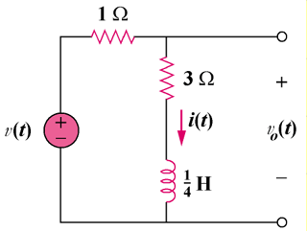

Figure 7.97
For Prob. 7.17.

